Demo Presentation

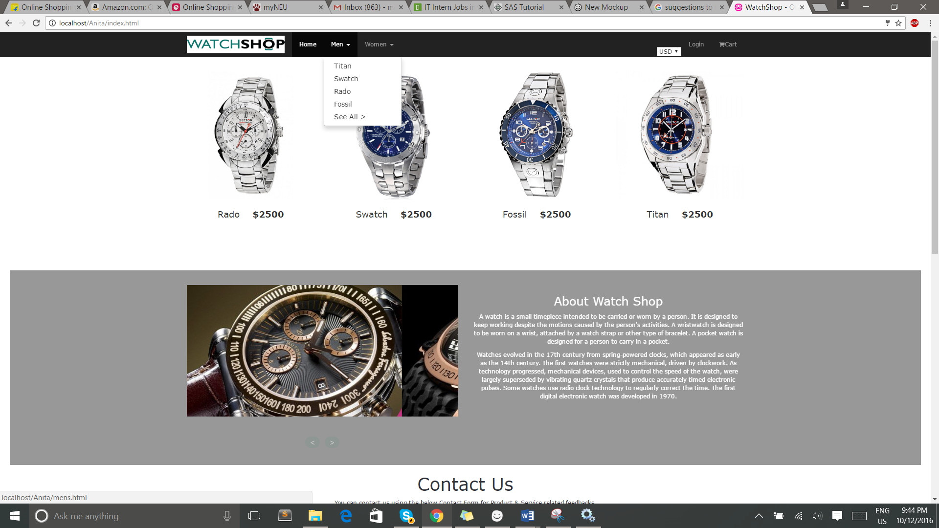

Main page having various functionality like category, login, contact details etc

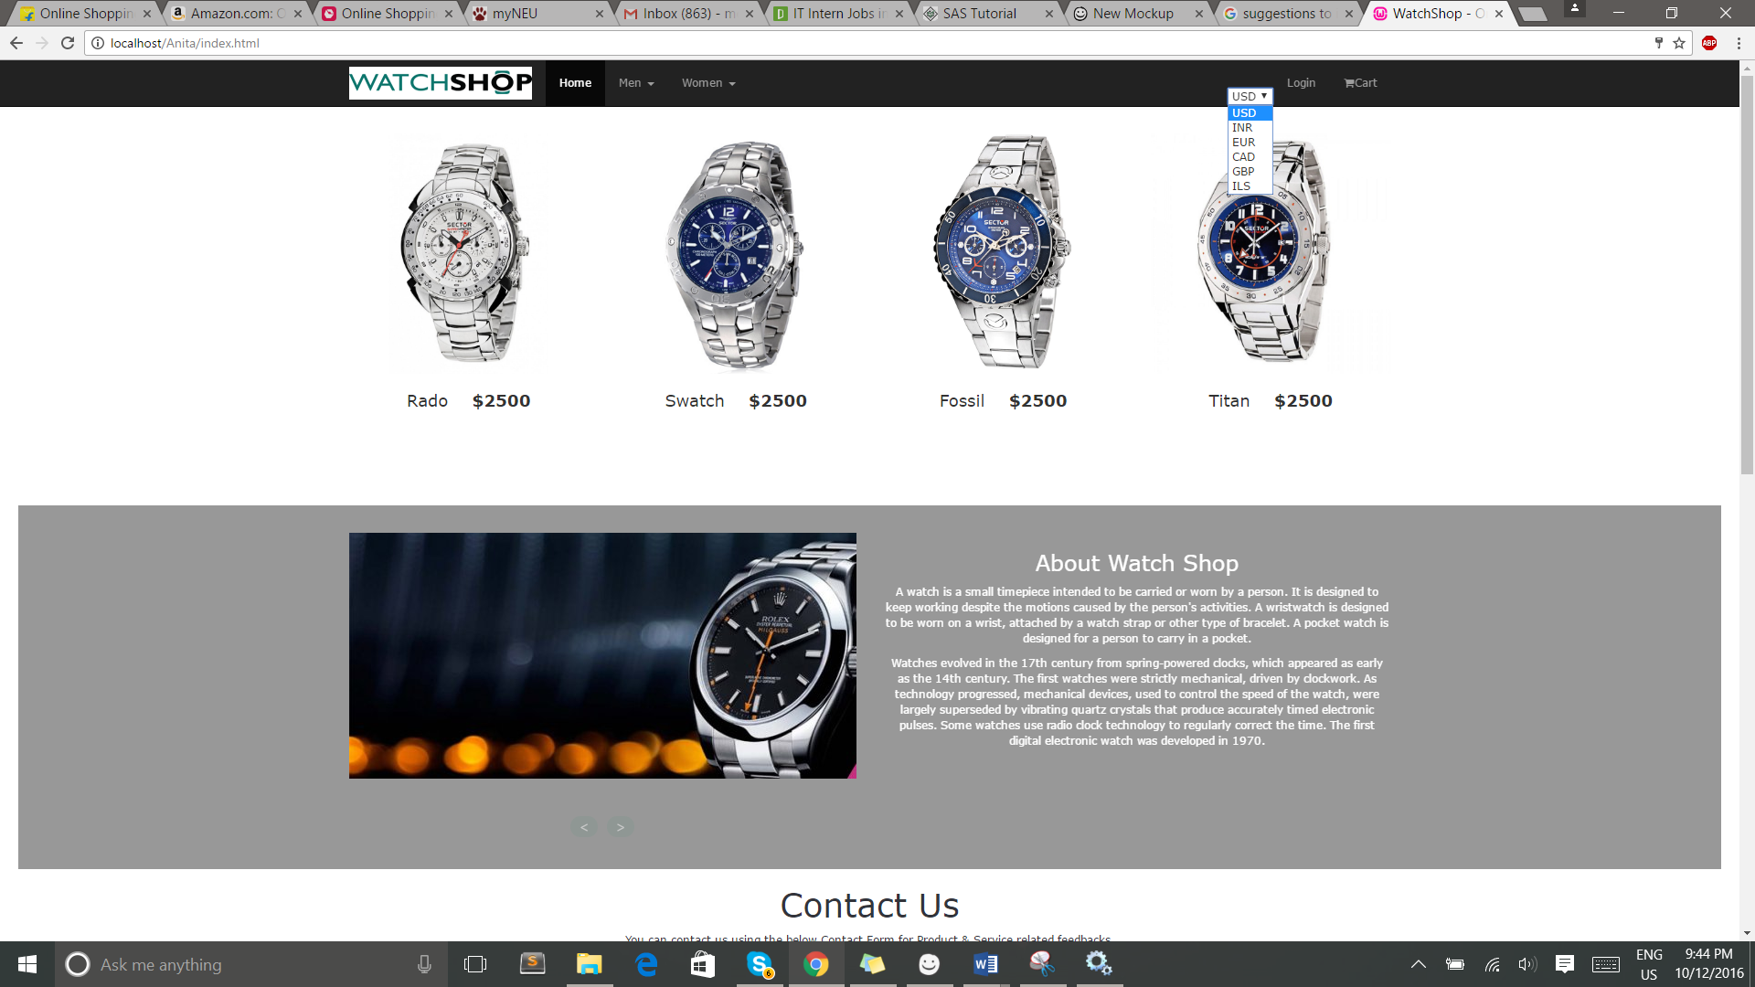

Showing currency change for various countries for users from various orgins.

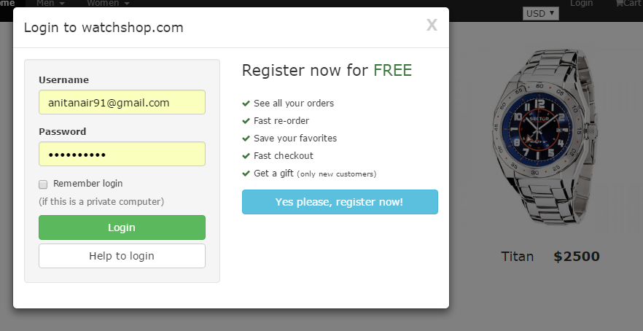

Login page with validations

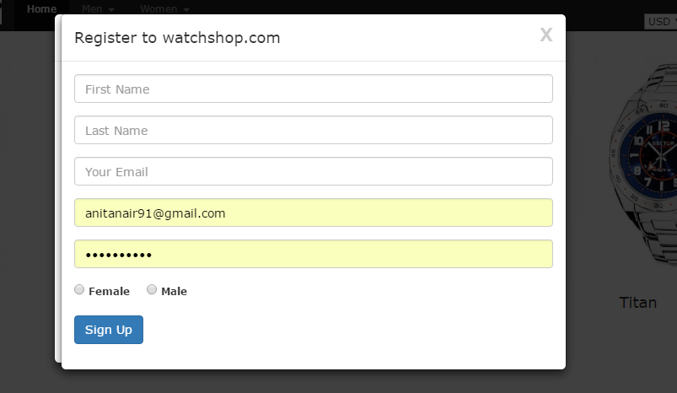

Registration page with validation with proper error messages displayed for 1st time users.

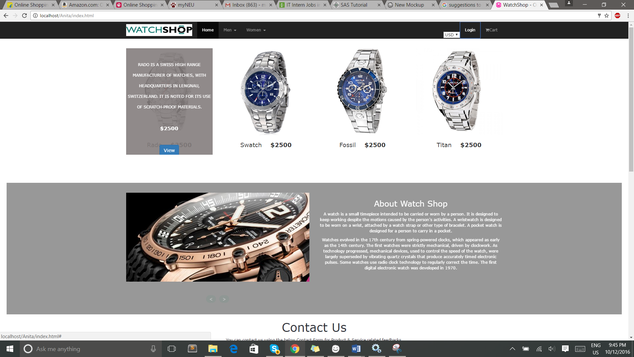

On hover of an image an option appears to view the product and add to cart.

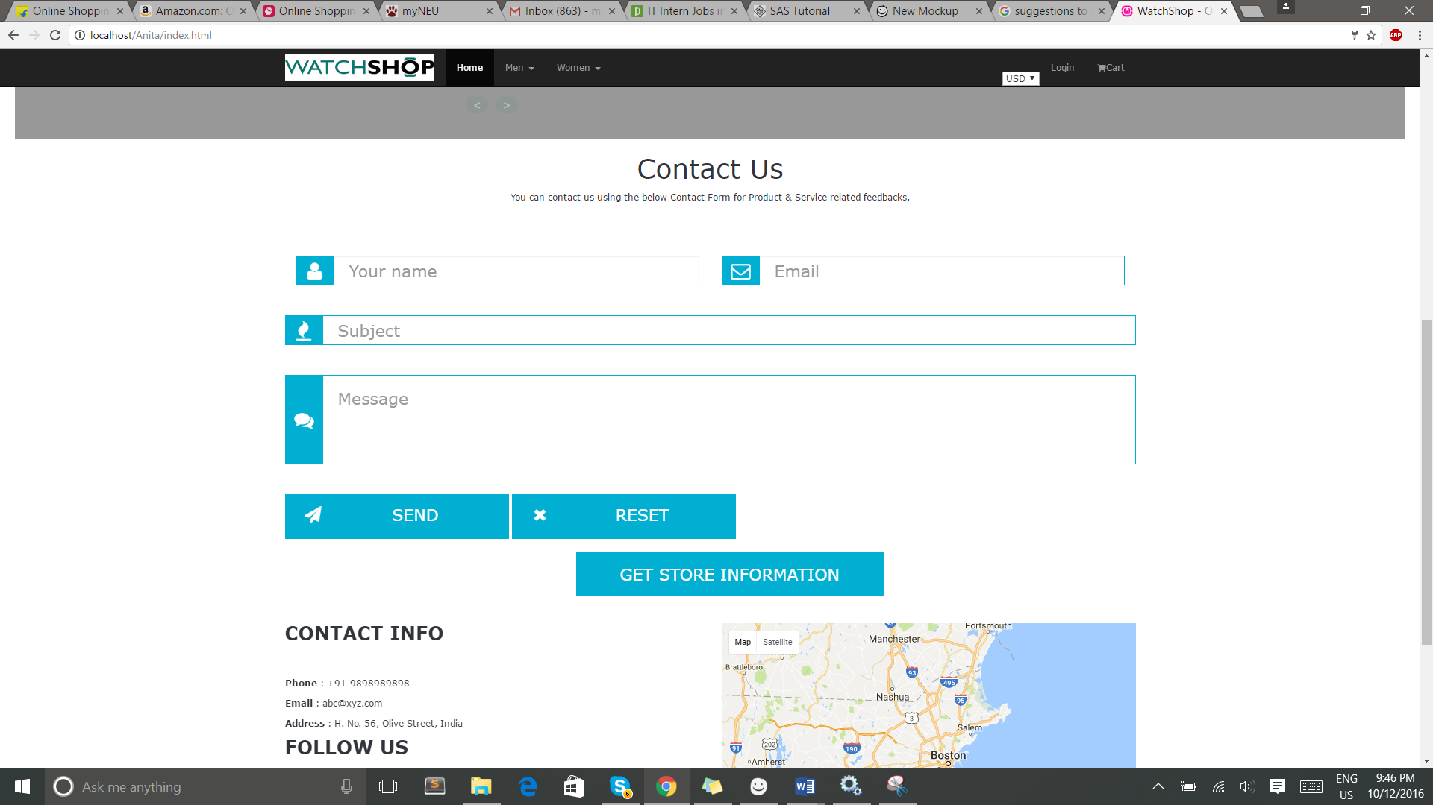

Contact Us form for any enquiry or customer satisfaction related questions.

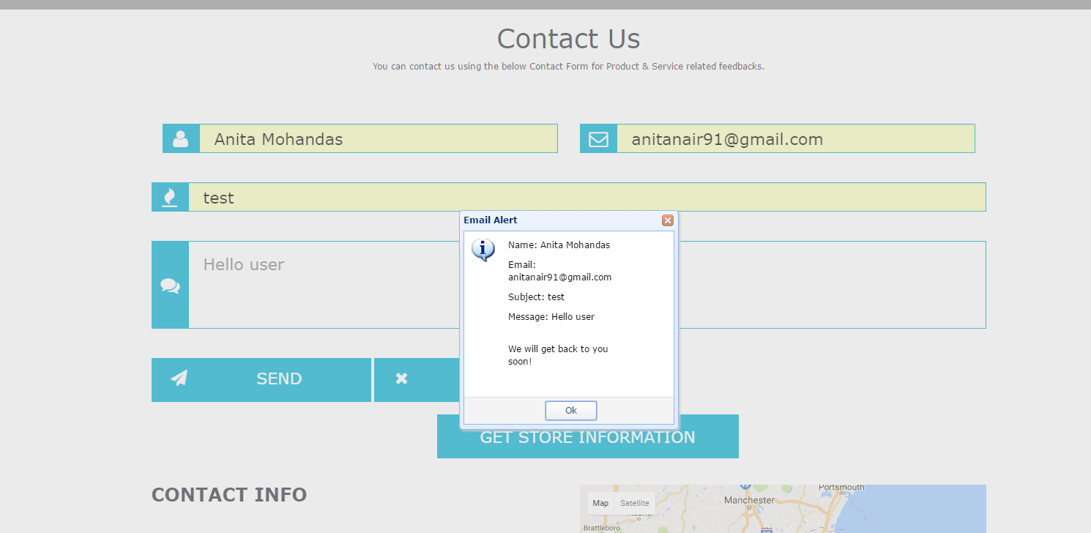

An email alert appearing showing an email send successfully.

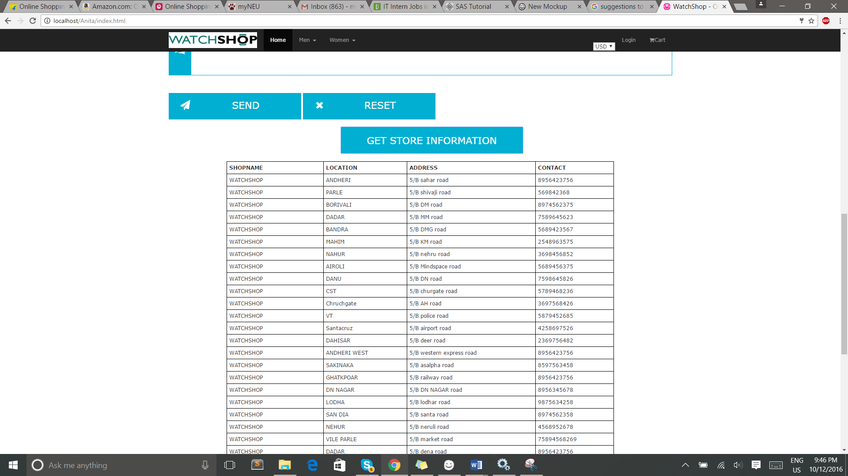

Physical store details of the outlet.

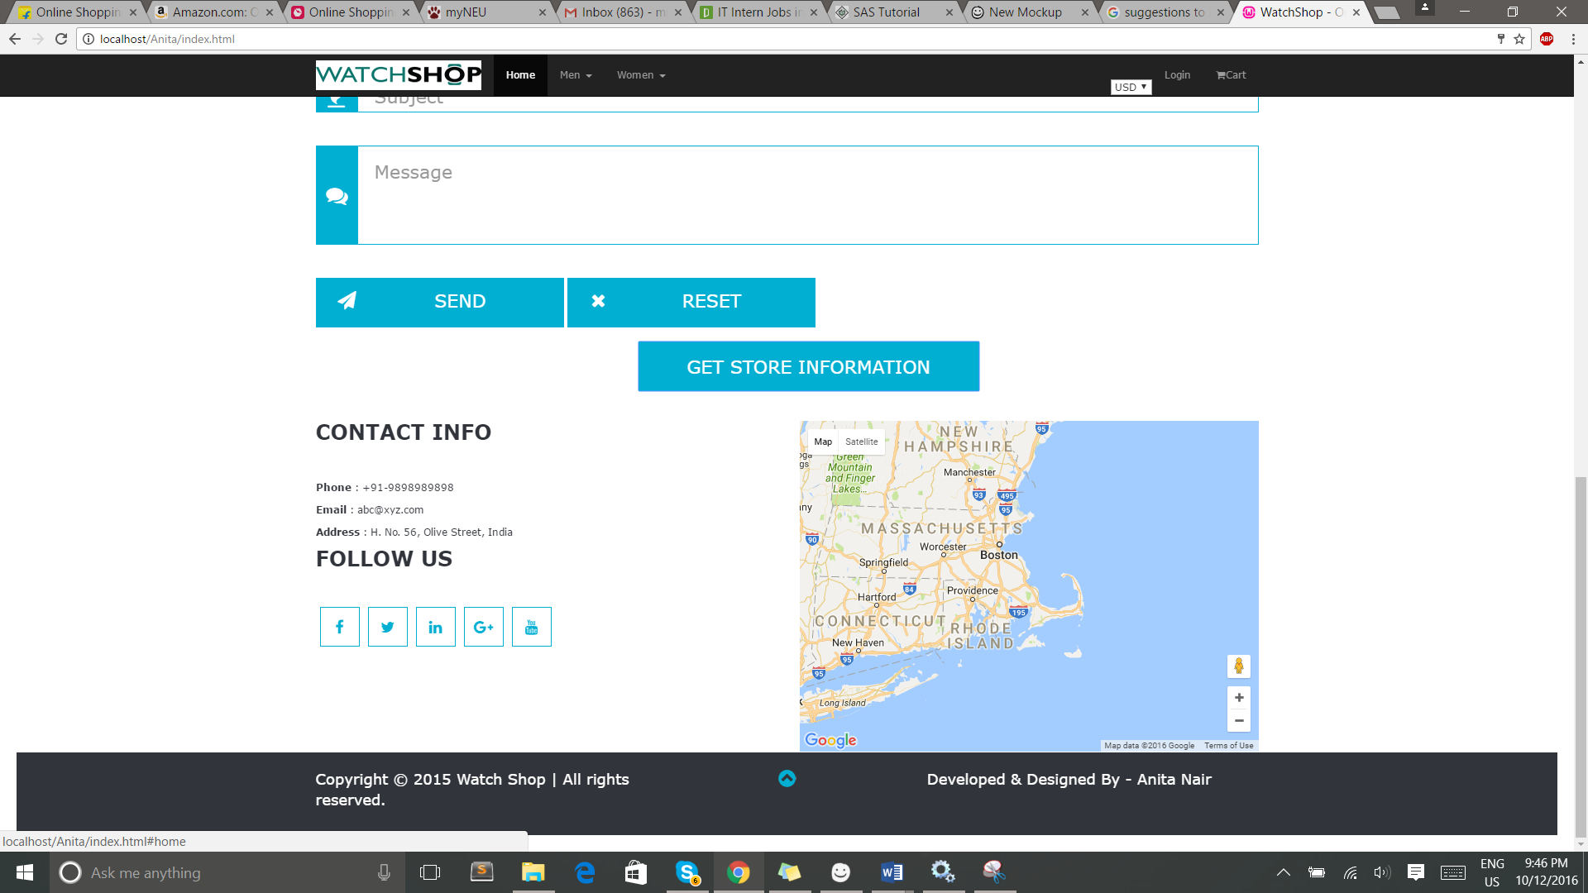

Back to top arrow showing good user experience.

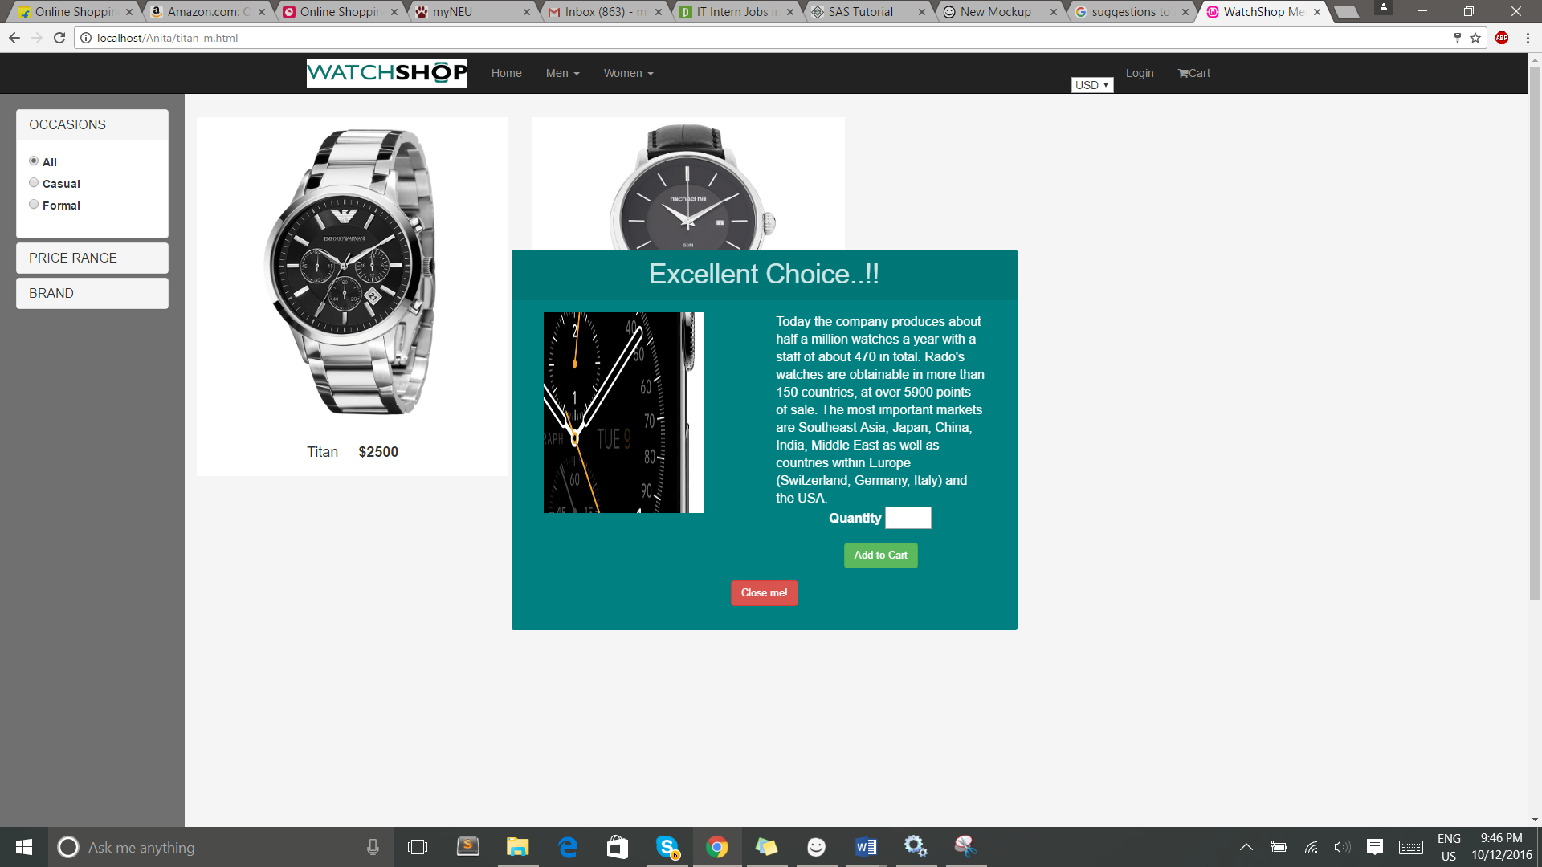

Add to cart option appearing for the product clicked with Quantity.

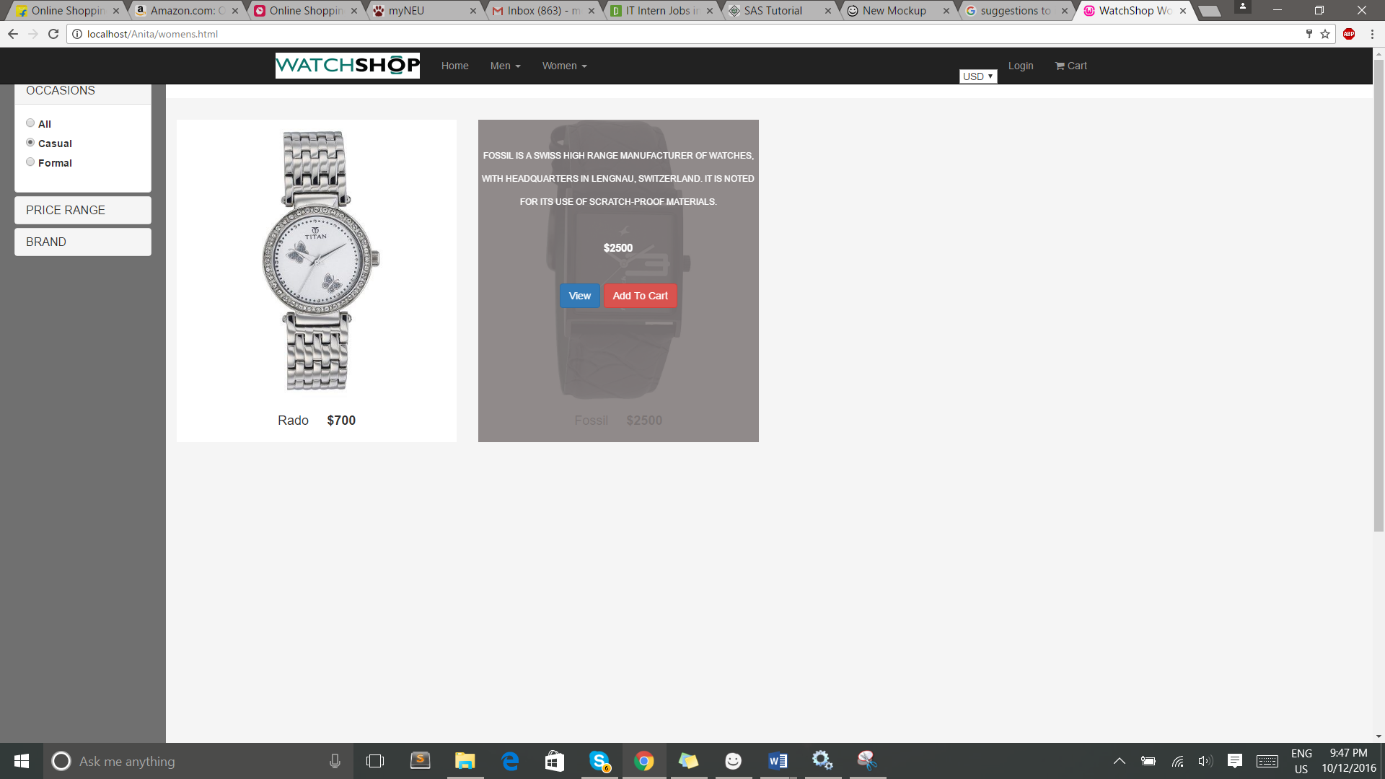

Filter options appearing on the side categorizing the products into casual and formal watches